Digital Communication Report

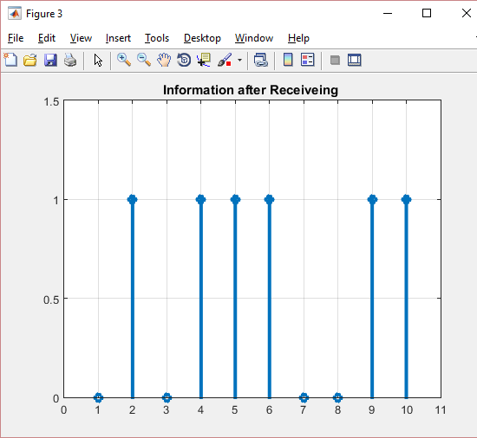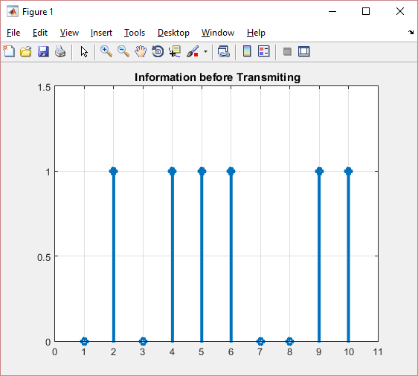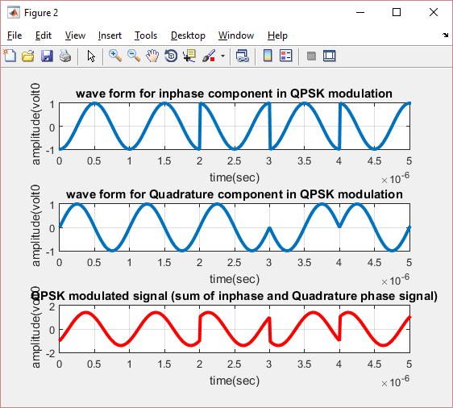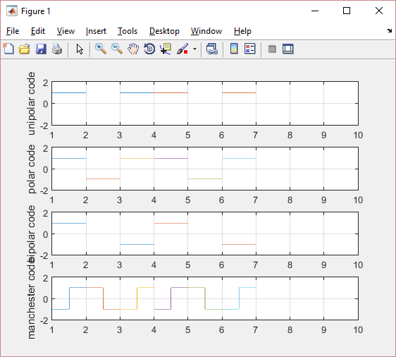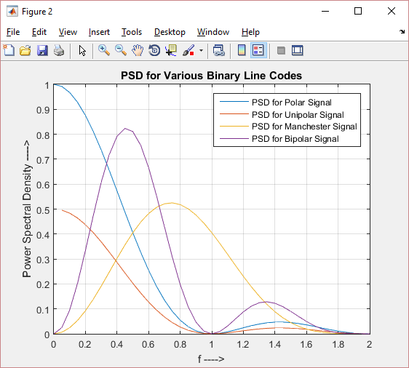

|  |  |
| --- | --- |
| Rajesh S | 1PI13EC074 |
| Sharath Rao | 1PI13EC091 |
| Sharath S Chellappa | 1PI13EC092 |

Aim: To execute FSK, ASK, PSK,QPSK, BPSK for a signal in Matlab and compare the Power Spectral Densities of the different types of line coding.

Theory:

Programs:

Line Coding techniques and their Power Spectral Densities –

clc;

close all;

clear all;

x=[1 0 1 1 0 1];

nx=size(x,2);

sign=1;

i=1;

while i<nx+1

t = i:0.001:i+1-0.001;

if x(i)==1

unipolar_code=square(t*2*pi,100);

polar_code=square(t*2*pi,100);

bipolar_code=sign*square(t*2*pi,100);

sign=sign*-1;

manchester_code=-square(t*2*pi,50);

else

unipolar_code=0;

polar_code=-square(t*2*pi,100);

bipolar_code=0;

manchester_code=square(t*2*pi,50);

end

subplot(4,1,1);

plot(t,unipolar_code);

ylabel('unipolar code');

hold on;

grid on;

axis([1 10 -2 2]);

subplot(4,1,2);

plot(t,polar_code);

ylabel('polar code');

hold on;

grid on;

axis([1 10 -2 2]);

subplot(4,1,3);

plot(t,bipolar_code);

ylabel('bipolar code');

hold on;

grid on;

axis([1 10 -2 2]);

subplot(4,1,4);

plot(t,manchester_code);

ylabel('manchester code');

hold on;

grid on;

axis([1 10 -2 2]);

i=i+1;

end

% Now we have to do PSD

%Input Parameters

Rb=1;

Tb=1/Rb;

f=0:0.05*Rb:2*Rb;

ax=f*Tb;

% PSD of Polar Signal

P=Tb*(sinc(ax).*sinc(ax));

% figure(1)

% plot(f,P,'r')

% grid on

% box on

% xlabel('f ---->')

% ylabel('Power Spectral Density ---->')

% title('PSD for Polar Signal')

% PSD of Unipolar Signal

P1=0.5*Tb*(sinc(ax).*sinc(ax))+ 0.5 *dirac(f);

% figure(2)

% plot(f,P1,'r')

% grid on

% box on

% xlabel('f ---->')

% ylabel('Power Spectral Density ---->')

% title('PSD for Unipolar Signal')

% PSD of Manchester Signal

P2=Tb*(sinc(ax/2)).^2.*(sin(pi*ax/2)).^2;

% figure(3)

% plot(f,P2,'r')

% grid on

% box on

% xlabel('f ---->')

% ylabel('Power Spectral Density ---->')

% title('PSD for Manchester Signal')

% PSD of Bipolar Signal

P3=Tb*(sinc(ax/2)).^2.*(sin(pi*ax)).^2;

% hold on

% figure(4)

% plot(f,P3,'r')

% grid on

% box on

% xlabel('f ---->')

% ylabel('Power Spectral Density ---->')

% title('PSD for Bipolar Signal')

%Final PSD of Binary line codes

hold on

figure(2)

plot(f,P,f,P1,f,P2,f,P3)

grid on

box on

xlabel('f ---->')

ylabel('Power Spectral Density ---->')

title('PSD for Various Binary Line Codes')

legend('PSD for Polar Signal','PSD for Unipolar Signal','PSD for Manchester Signal','PSD for Bipolar Signal')

Output:



PSK:

Output:

FSK:

Output:

ASK:

Output:

QPSK :

clc;

clear all;

close all;

data=[0 1 0 1 1 1 0 0 1 1]; % information

%Number_of_bit=1024;

%data=randint(Number_of_bit,1);

figure(1)

stem(data, 'linewidth',3), grid on;

title(' Information before Transmiting ');

axis([ 0 11 0 1.5]);

data_NZR=2*data-1; % Data Represented at NZR form for QPSK modulation

s_p_data=reshape(data_NZR,2,length(data)/2); % S/P convertion of data

br=10.^6; %Let us transmission bit rate 1000000

f=br; % minimum carrier frequency

T=1/br; % bit duration

t=T/99:T/99:T; % Time vector for one bit information

% XXXXXXXXXXXXXXXXXXXXXXX QPSK modulatio XXXXXXXXXXXXXXXXXXXXXXXXXXXXXXXXX

y=[];

y_in=[];

y_qd=[];

for(i=1:length(data)/2)

y1=s_p_data(1,i)*cos(2*pi*f*t); % inphase component

y2=s_p_data(2,i)*sin(2*pi*f*t) ;% Quadrature component

y_in=[y_in y1]; % inphase signal vector

y_qd=[y_qd y2]; %quadrature signal vector

y=[y y1+y2]; % modulated signal vector

end

Tx_sig=y; % transmitting signal after modulation

tt=T/99:T/99:(T*length(data))/2;

figure(2)

subplot(3,1,1);

plot(tt,y_in,'linewidth',3), grid on;

title(' wave form for inphase component in QPSK modulation ');

xlabel('time(sec)');

ylabel(' amplitude(volt0');

subplot(3,1,2);

plot(tt,y_qd,'linewidth',3), grid on;

title(' wave form for Quadrature component in QPSK modulation ');

xlabel('time(sec)');

ylabel(' amplitude(volt0');

subplot(3,1,3);

plot(tt,Tx_sig,'r','linewidth',3), grid on;

title('QPSK modulated signal (sum of inphase and Quadrature phase signal)');

xlabel('time(sec)');

ylabel(' amplitude(volt0');

% XXXXXXXXXXXXXXXXXXXXXXXXXXXX QPSK demodulation XXXXXXXXXXXXXXXXXXXXXXXXXX

Rx_data=[];

Rx_sig=Tx_sig; % Received signal

for(i=1:1:length(data)/2)

%%XXXXXX inphase coherent dector XXXXXXX

Z_in=Rx_sig((i-1)*length(t)+1:i*length(t)).*cos(2*pi*f*t);

% above line indicat multiplication of received & inphase carred signal

Z_in_intg=(trapz(t,Z_in))*(2/T);% integration using trapizodial rull

if(Z_in_intg>0) % Decession Maker

Rx_in_data=1;

else

Rx_in_data=0;

end

%%XXXXXX Quadrature coherent dector XXXXXX

Z_qd=Rx_sig((i-1)*length(t)+1:i*length(t)).*sin(2*pi*f*t);

%above line indicat multiplication ofreceived & Quadphase carred signal

Z_qd_intg=(trapz(t,Z_qd))*(2/T);%integration using trapizodial rull

if (Z_qd_intg>0)% Decession Maker

Rx_qd_data=1;

else

Rx_qd_data=0;

end

Rx_data=[Rx_data Rx_in_data Rx_qd_data]; % Received Data vector

end

figure(3)

stem(Rx_data,'linewidth',3)

title('Information after Receiveing ');

axis([ 0 11 0 1.5]), grid on;

Output:



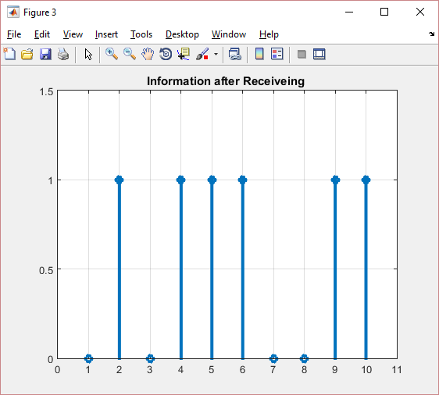

BPSK:

Output:

Result: The ASK, FSK, PSK, QPSK and BPSK for a signal were plotted and the Power spectral densities of the different types of line encoding were compared.